Belly Dance: Shimmy and Shimmer
9 – 12 Saturday May 30th
Instructor – ‘Tamara’

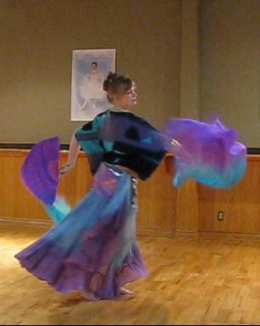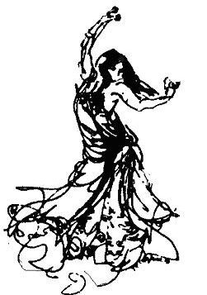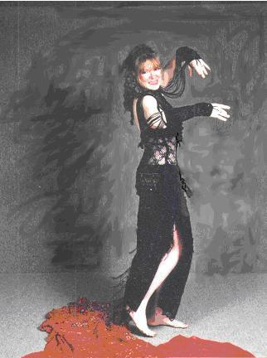

Come join me, Tamara, and learn about some of the history and moves and costume styles of this ancient and beautiful dance. We'll briefly explore the history of 'el raqs'. We'll learn some of the basics during the 'lesson'* including learning how to fly veils. And finally we'll get to explore the world of costumes in all their jingly and sparkly glory. Belly Dance, it's not what Hollywood thinks it is...it's more! What's 'el raqs'? Come to the workshop to find out.
Level - * light physical activity suitable for all ages and types. Wear something loose and comfortable. Soft soled shoes (not sneakers) or bare feet recommended.

Supply Fee – none
See also http://dancetamara.ca/

