Chainmaile Jewelry 9 – 12 Saturday May 30th
Instructor – Cherida McCullagh
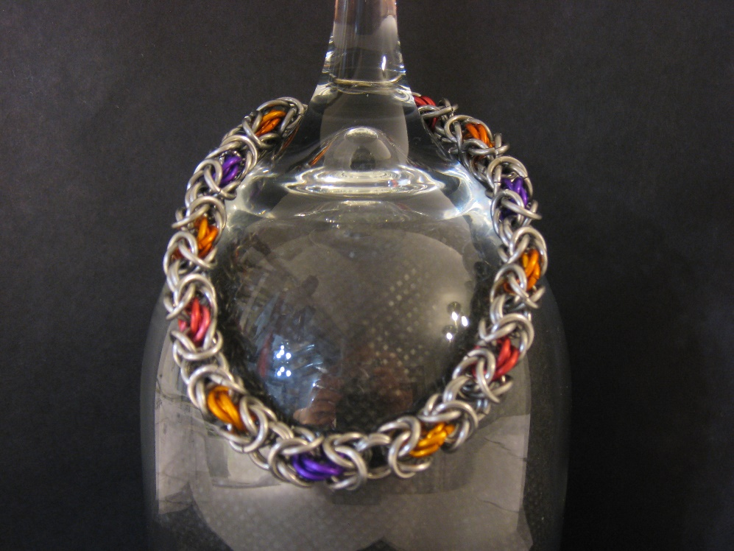

Medieval soldiers relied on this fascinating technique to make armor but today it is popular for all kinds of unique jewelry. It is created by connecting metal rings to one another to create endless combinations.
Participants will learn this basic Byzantine weave shown in the photo.
All Levels
Supply fee - $12 – kit with all rings and clasp
See more of Cherida’s work https://www.facebook.com/pages/Canadian-Made-Creations/169579389766061

