Drawing 9 – 12 Saturday, May 30th
Instructors – Anne Hamilton and Tristan Eekhoff

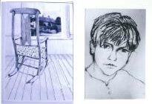
Graphite Charcoal
Anne Hamilton Tristan Eekhoff

Drawing is at the root of all artwork – painting, sculpture, printmaking, design…..The techniques, discipline and the meaning of drawing will be discussed and then practised with reference to paintings, drawings and prints from both past and modern.
Students will learn how to draw different objects with the use of perspective and a variety of shading techniques. Several drawing media will also be explored.

Level – Introductory Supply Fee - $10

