Fibre Art - 1:30 – 4:30 Saturday May 30th
Instructor – Cynthia McNair See http://www.cynthiamcnair.com/ 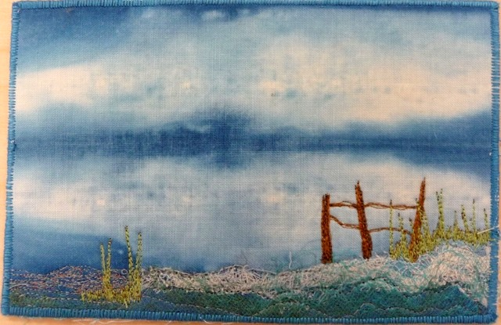
This will be a three hour class taking people through the process of making a 4x6 inch fabric postcard. Dyed backgrounds, stabilizer, silk rovings and other materials will be supplied.
Students will need to bring an assortment of threads, sewing machine and anything else they would like to use.
Level – introductory Supply Fee - $5

