Introduction to Wildlife Photography
Instructor – David Bishop 1:30 – 4:30 Saturday, May 30th
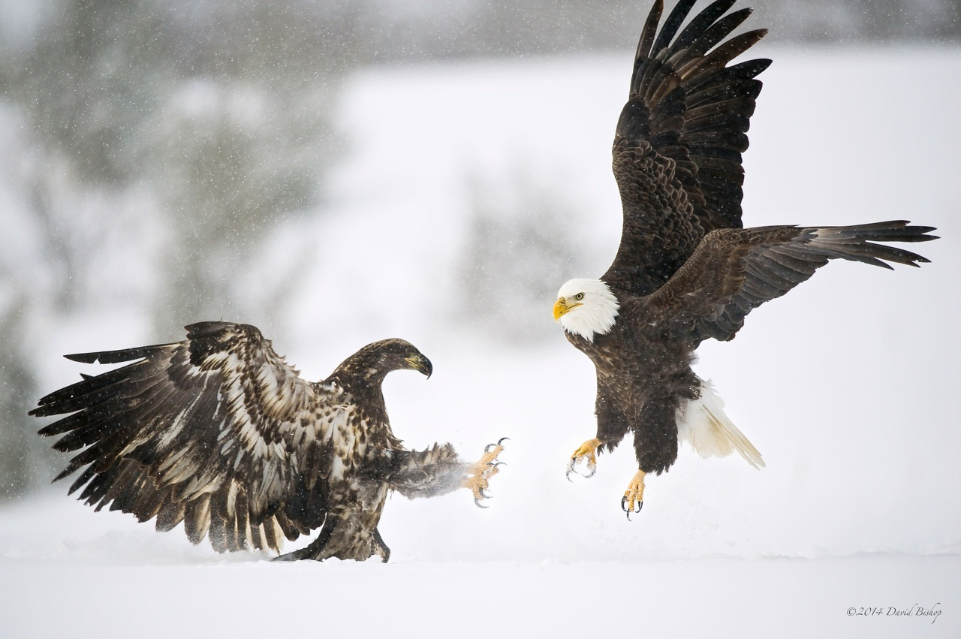
While David Bishop was gifted his first camera as a wedding present 30 years ago, he got serious about photography about six years ago. Bishop’s time in the field taking pictures is relegated to weekends and vacation time. He specializes in wildlife and landscape photography and has a large number of photos featured in the book, The Beauty and Bounty of Huron County. This class is a great opportunity for an introduction to wildlife and outdoor photography with a lot of helpful tips
Students will learn how to prepare and successfully capture those still and elusive action shots, and return home at the end of the day with more ‘keepers’.
What Student is expected to Learn: Framing the best shot, proper exposure, selecting the correct shutter speeds, using the magic of light, and simple editing techniques.
You will need a digital camera and camera card for this class. DSLR’s preferred.
If weather permits it will be an outdoor learning experience. Wear comfortable shoes and appropriate clothing.
Level – introductory Supply Fee - none

