Soapstone Sculpture 9 – 12 Saturday May 30th
Instructor – Joe Haygarth
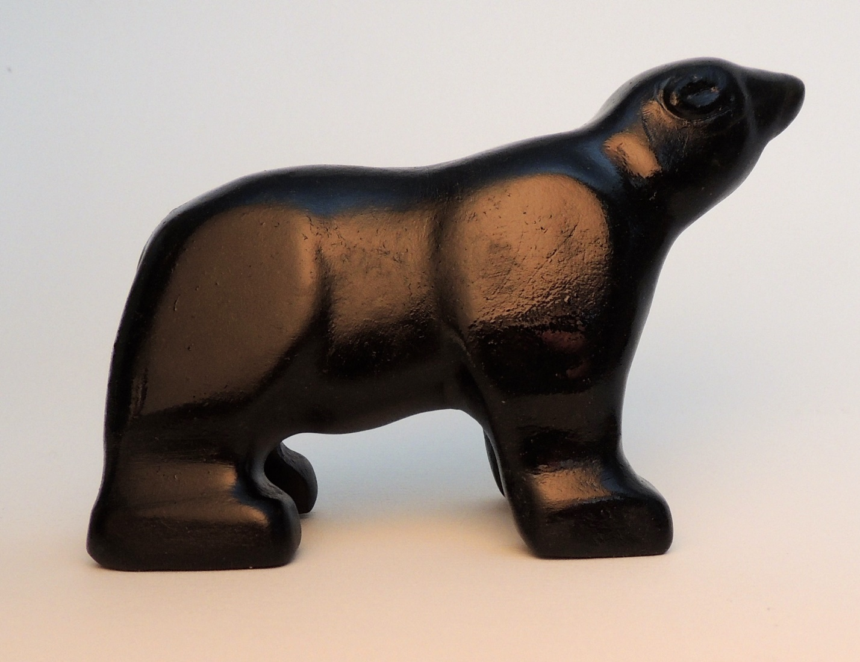
Students will learn the basic techniques of soapstone carving (material properties, safe handling, finishes) and take your sculpture home with you. Tools (mini hacksaw, round and half round rasp, rifflers, and silicon carbide waterproof paper) and stone for your first project, “Standing Bear”, are provided, but protective eyewear and appropriate clothing are recommended.

Level - introductory
Supply Fee - $10

