Watercolour Batik 1:30- 4:30 Saturday May 30th
Instructor – Lynn Haygarth

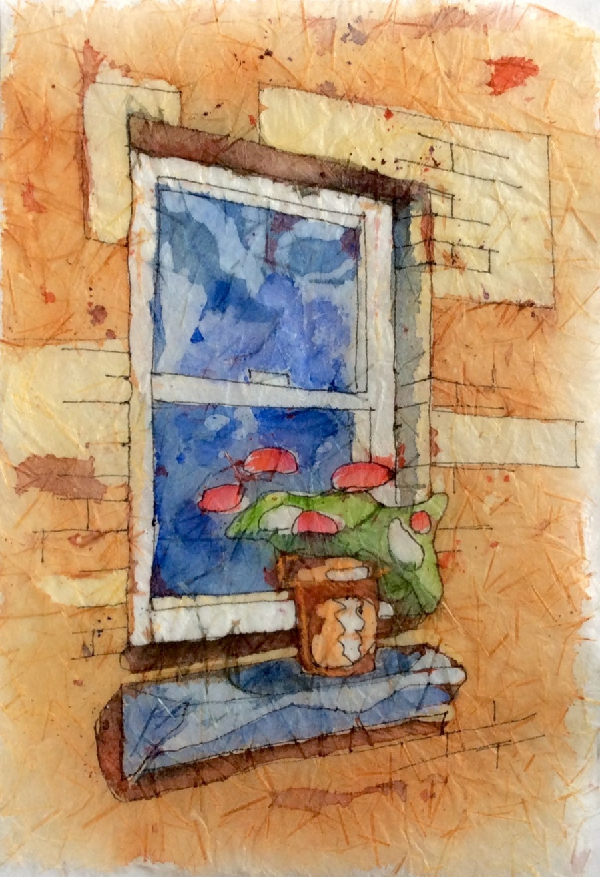
‘Geraniums in the Window’

Using wax as a resist and many layers of transparent watercolours students will learn the art of batik. Once all the painting is finished the wax is removed and a colourful painting materializes.

Level – introductory
Supply Fee - $10 See also www.paintingclass.ca

